Create, Update and Remove Software in Linux

Head's up: You'll experience a delay as the labs initially load, particularly for Windows labs.

**Introduction**

This lab focuses on installing and removing software in Linux, and working with zipped files.

**What you’ll do**

You’ll be installing a text editor called Atom, and extracting/un-extracting .tar files. You’ll also use apt-get to install/uninstall programs.

**You will have 60 minutes to complete this lab.**

# **Software Packages and File Archives on Linux**

External IP address



content\_copy

username



content\_copy

[file\_download](https://googlecoursera.qwiklabs.com/lab_instances/download_pem/15716162" \t "_blank)

[Download PEM](https://googlecoursera.qwiklabs.com/lab_instances/download_pem/15716162" \t "_blank)

[file\_download](https://googlecoursera.qwiklabs.com/lab_instances/download_ppk/15716162" \t "_blank)

[Download PPK](https://googlecoursera.qwiklabs.com/lab_instances/download_ppk/15716162" \t "_blank)

## Introduction

This lab focuses on installing and removing software in Linux, and working with zipped files. You'll be installing a text editor called Atom, and extracting/un-extracting .tar files. You'll also use **apt** to install/uninstall programs.

**Head's up**: You'll experience a delay as the labs initially load (particularly for Windows labs). So, please **wait a couple of minutes for the labs to load**. Please also make sure to access the labs **directly through Coursera** and not in the Qwiklabs catalog. If you access the labs through the Qwiklabs catalog, you will **not** receive a grade. (As you know, a passing grade is required to matriculate through the course.) The grade is calculated when the lab is complete, so be sure to hit "**End Lab**" when you're done!

You'll have 60 minutes to complete this lab.

### Start the lab

You'll need to start the lab before you can access the materials in the virtual machine OS. To do this, click the green “Start Lab” button at the top of the screen.

**Note:** For this lab you are going to access the **Linux VM** through your **local SSH Client**, and not use the **Google Console** (**Open GCP Console** button is not available for this lab).

Start Lab

After you click the “Start Lab” button, you will see all the SSH connection details on the left-hand side of your screen. You should have a screen that looks like this:

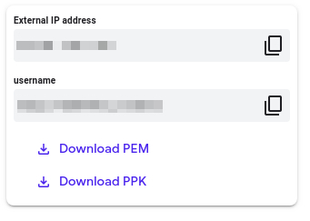

## Accessing the virtual machine

Please find one of the three relevant options below based on your device's operating system.

**Note:** Working with Qwiklabs may be similar to the work you'd perform as an **IT Support Specialist**; you'll be interfacing with a cutting-edge technology that requires multiple steps to access, and perhaps healthy doses of patience and persistence(!). You'll also be using **SSH** to enter the labs -- a critical skill in IT Support that you’ll be able to practice through the labs.

### Option 1: Windows Users: Connecting to your VM

In this section, you will use the PuTTY Secure Shell (SSH) client and your VM’s External IP address to connect.

**Download your PPK key file**

You can download the VM’s private key file in the PuTTY-compatible **PPK** format from the Qwiklabs Start Lab page. Click on **Download PPK**.

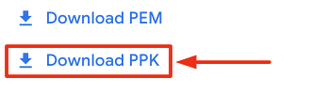

**Connect to your VM using SSH and PuTTY**

1. You can download Putty from [here](https://the.earth.li/~sgtatham/putty/latest/w64/putty.exe)
2. In the **Host Name (or IP address)** box, enter username@external\_ip\_address.

**Note:** Replace **username** and **external\_ip\_address** with values provided in the lab.



1. In the **Category** list, expand **SSH**.
2. Click **Auth** (don’t expand it).
3. In the **Private key file for authentication** box, browse to the PPK file that you downloaded and double-click it.
4. Click on the **Open** button.

**Note:** PPK file is to be imported into PuTTY tool using the Browse option available in it. It should not be opened directly but only to be used in PuTTY.



1. Click **Yes** when prompted to allow a first connection to this remote SSH server. Because you are using a key pair for authentication, you will not be prompted for a password.

**Common issues**

If PuTTY fails to connect to your Linux VM, verify that:

* You entered **<username>**@**<external ip address>** in PuTTY.
* You downloaded the fresh new PPK file for this lab from Qwiklabs.
* You are using the downloaded PPK file in PuTTY.

### Option 2: OSX and Linux users: Connecting to your VM via SSH

**Download your VM’s private key file.**

You can download the private key file in PEM format from the Qwiklabs Start Lab page. Click on **Download PEM**.

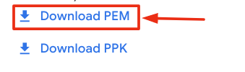

**Connect to the VM using the local Terminal application**

A **terminal** is a program which provides a **text-based interface for typing commands**. Here you will use your terminal as an SSH client to connect with lab provided Linux VM.

1. Open the Terminal application.
   * To open the terminal in Linux use the shortcut key **Ctrl+Alt+t**.
   * To open terminal in **Mac** (OSX) enter **cmd + space** and search for **terminal**.
2. Enter the following commands.

**Note:** Substitute the **path/filename for the PEM** file you downloaded, **username** and **External IP Address**.

You will most likely find the PEM file in **Downloads**. If you have not changed the download settings of your system, then the path of the PEM key will be **~/Downloads/qwikLABS-XXXXX.pem**

chmod 600 ~/Downloads/qwikLABS-XXXXX.pem

ssh -i ~/Downloads/qwikLABS-XXXXX.pem username@External Ip Address

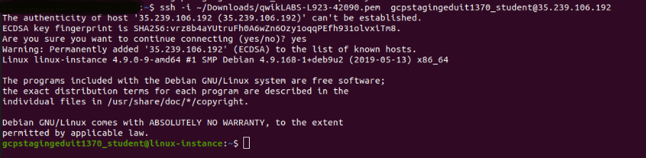

### Option 3: Chrome OS users: Connecting to your VM via SSH

**Note:** Make sure you are not in **Incognito/Private mode** while launching the application.

**Download your VM’s private key file.**

You can download the private key file in PEM format from the Qwiklabs Start Lab page. Click on **Download PEM**.



**Connect to your VM**

1. Add Secure Shell from [here](https://chrome.google.com/webstore/detail/secure-shell-app/pnhechapfaindjhompbnflcldabbghjo) to your Chrome browser.
2. Open the Secure Shell app and click on **[New Connection]**.

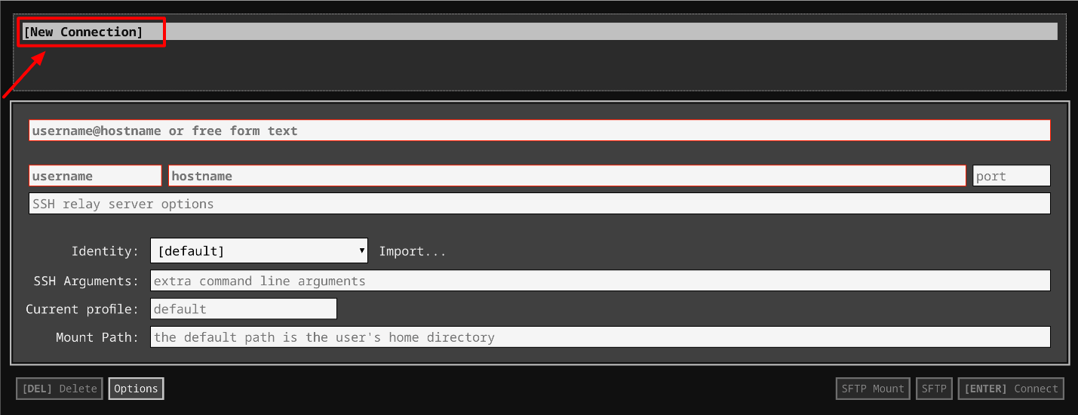

1. In the **username** section, enter the username given in the Connection Details Panel of the lab. And for the **hostname** section, enter the external IP of your VM instance that is mentioned in the Connection Details Panel of the lab.

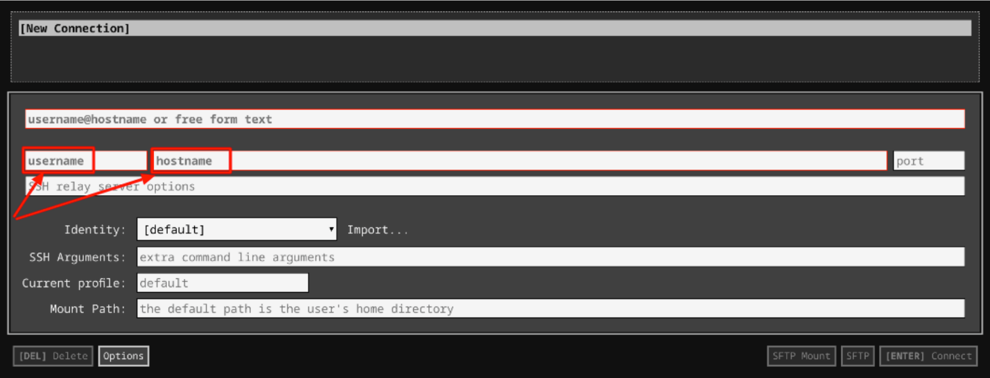

1. In the **Identity** section, import the downloaded PEM key by clicking on the **Import…** button beside the field. Choose your PEM key and click on the **OPEN** button.

**Note:** If the key is still not available after importing it, refresh the application, and select it from the **Identity** drop-down menu.

1. Once your key is uploaded, click on the **[ENTER] Connect** button below.

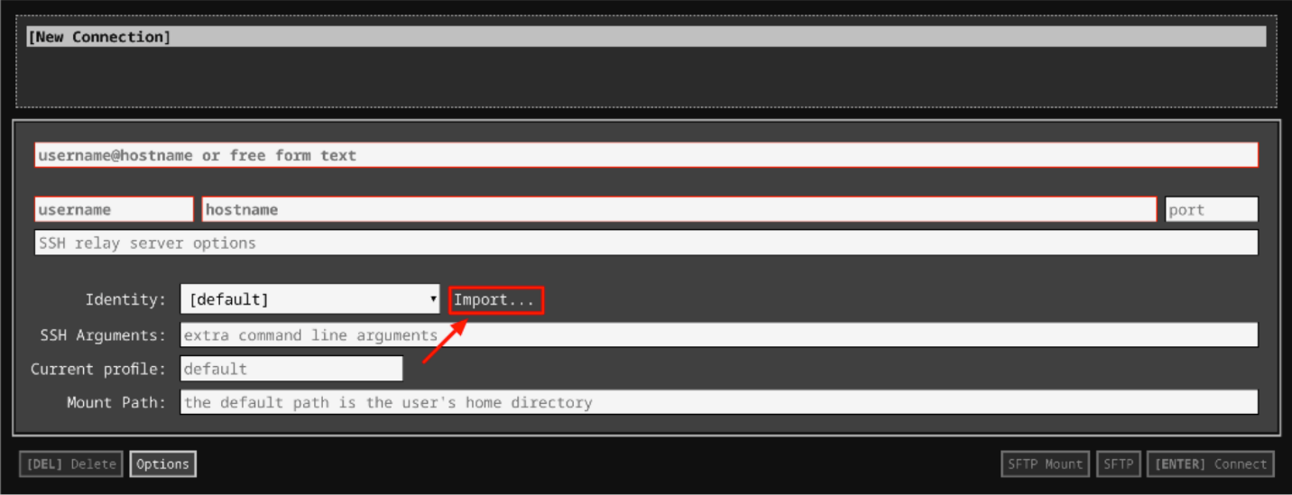

1. For any prompts, type **yes** to continue.
2. You have now successfully connected to your Linux VM.

You're now ready to continue with the lab!

## Installing Atom

First, use dpkg to install a text editor, called Atom. A .deb file is located at "/home/qwiklab/downloads/atom-amd64.deb", which you can install using this command:

sudo dpkg -i /home/qwiklab/downloads/atom-amd64.deb

You'll see some errors after this command, but that's okay! The atom package has some dependencies that aren't installed on your machine yet, and dpkg is just warning you that they need to be installed:

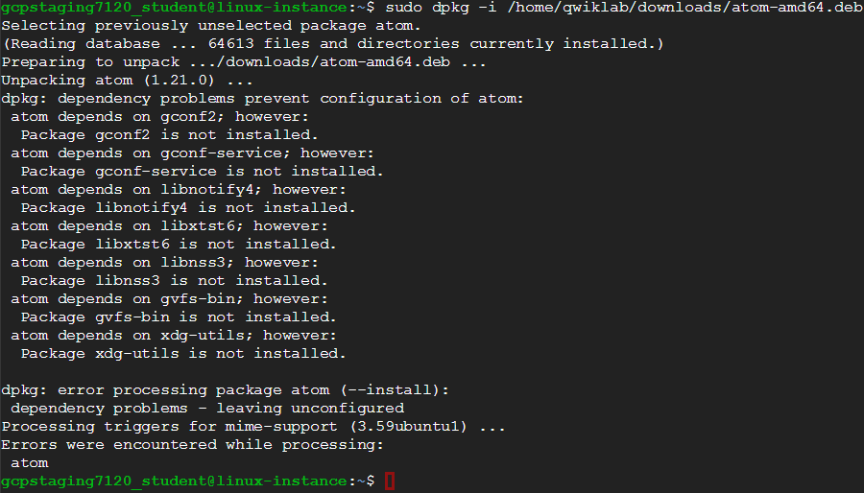

You can remedy this by using **apt** to fix the missing dependencies, using this command:

sudo apt install -f

You'll be prompted to confirm your decision to continue with the operation by typing "Y" (for "Yes"), midway through the process.

Now Atom is successfully installed, which you can verify using dpkg:

dpkg -s atom

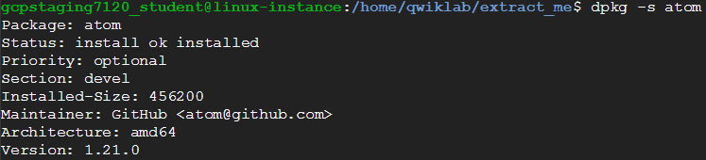

Click Check my progress to verify the objective.

Install Atom

Check my progress

## Extracting an archive

Next, you will extract a .tar archive. The archive "extract\_me.tar" is located in "/home/qwiklab/downloads/". Move to that directory, using this command:

cd /home/qwiklab/downloads

You can use the Linux tar command to extract it using this command:

sudo tar -xvf extract\_me.tar

The contents of the archive (the file named "great\_job") are then extracted:



Click Check my progress to verify the objective.

Extract Archive

Check my progress

## Archiving files

First, move back to the original directory:

cd ~

You can also use the tar command to do the reverse operation, creating an archive. There are three files in your /home/qwiklab/documents folder named "Earth", "Mercury", and "Venus". Use tar to archive them into the file "Planets.tar" using this command (one line):

tar -cvf Planets.tar /home/qwiklab/documents/Earth /home/qwiklab/documents/Mercury /home/qwiklab/documents/Venus

"Planets.tar" will then be added to your current directory, and will contain the three planet files:

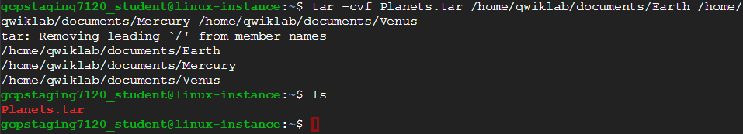

Click Check my progress to verify the objective.

Archive Files

Check my progress

## Installing 7-Zip

You can also install programs on Linux, using **apt** too, which handles dependencies for you to simplify the installation process. You can install the program 7-Zip, using **apt**, with a simple one-line command:

sudo apt install p7zip-full

When it's finished, 7-Zip will be installed:

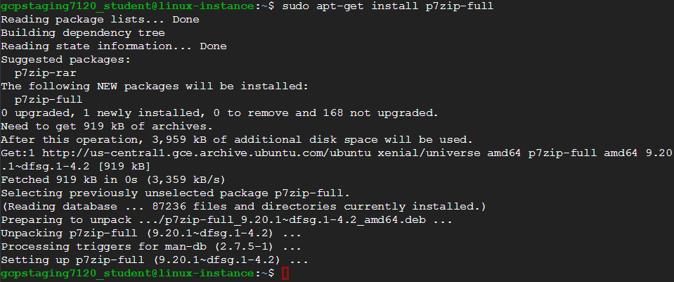

You can verify the installation using dpkg, with this command:

dpkg -s p7zip-full

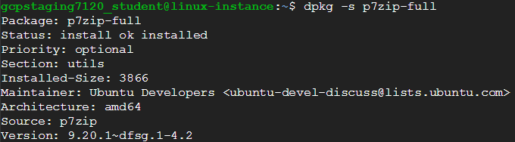

Click Check my progress to verify the objective.

Install 7-Zip

Check my progress

## Uninstalling GIMP

Uninstallation can also be handled by **apt** by using "remove" instead of "install" as the argument. GIMP, an image-editing program, is already installed on your machine. Uninstall it now, using **apt** with this command:

sudo apt remove gimp

You'll be prompted to confirm your decision midway through the uninstallation process. Confirm this by typing "Y" (for "Yes"). Then, GIMP will be uninstalled:

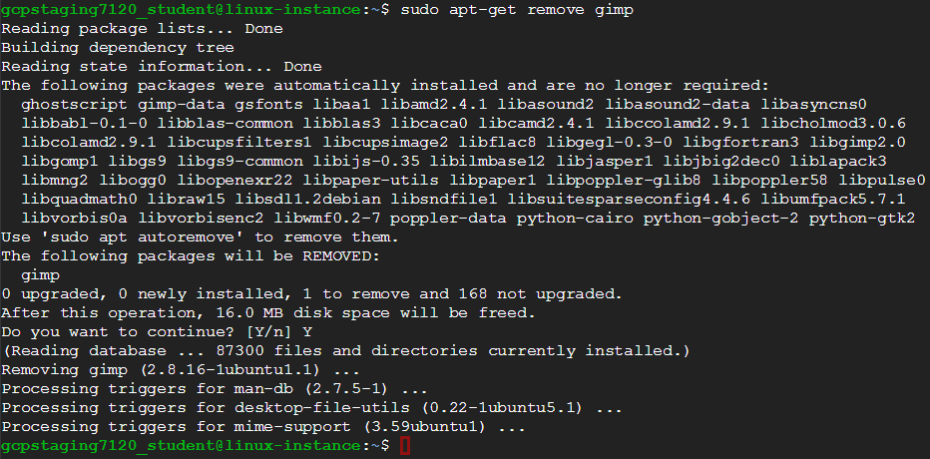

You can verify this using dpkg (like before) with this command:

dpkg -s gimp

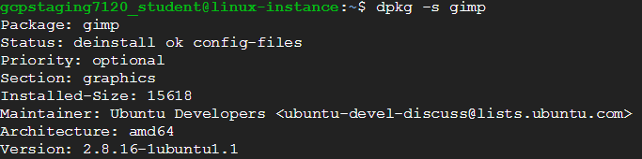

Click Check my progress to verify the objective.

Uninstall GIMP

Check my progress

## Conclusion

Congrats! You've successfully installed and uninstalled programs on Linux, and archived and unarchived .tar files.

## End your lab